**Test Cases and Results**

Design test cases using black box and white box testing techniques

Design test cases using equivalence class and boundary value testing techniques to test one important control class that implements some important application logic according to the requirements specification

**Black box testing**

Since there is **no boundary value testing** available for any of our functions, we will only be conducting an equivalence class.

UC012: Update Account Details

Inputs

| Login | Update profile pic | Update Full name | Update username | Update Website | Expected Output | Actual Output |
| --- | --- | --- | --- | --- | --- | --- |
| Yes | Yes | Yes | Yes | Yes | Account details will show updated profile picture, full name, username and website | Account details will show updated profile picture, full name, username and website |
| Yes | No | Yes | Yes | Yes | Account details will show updated full name, username and website | Account details will show updated full name, username and website |
| Yes | Yes | No | Yes | Yes | Account details will show updated profile picture, username and website | Account details will show updated profile picture, username and website |
| Yes | Yes | Yes | No | Yes | Account details will show updated profile picture, full name and website | Account details will show updated profile picture, full name and website |
| Yes | Yes | Yes | Yes | No | Account details will show updated profile picture, full name and username | Account details will show updated profile picture, full name and username |
| No | NULL | NULL | NULL | NULL | Update Account detail page not shown | Update Account detail page not shown |

**White Box Testing**

Design test cases using basis path testing techniques to test two methods that implement complex application logic.

Update Account Details

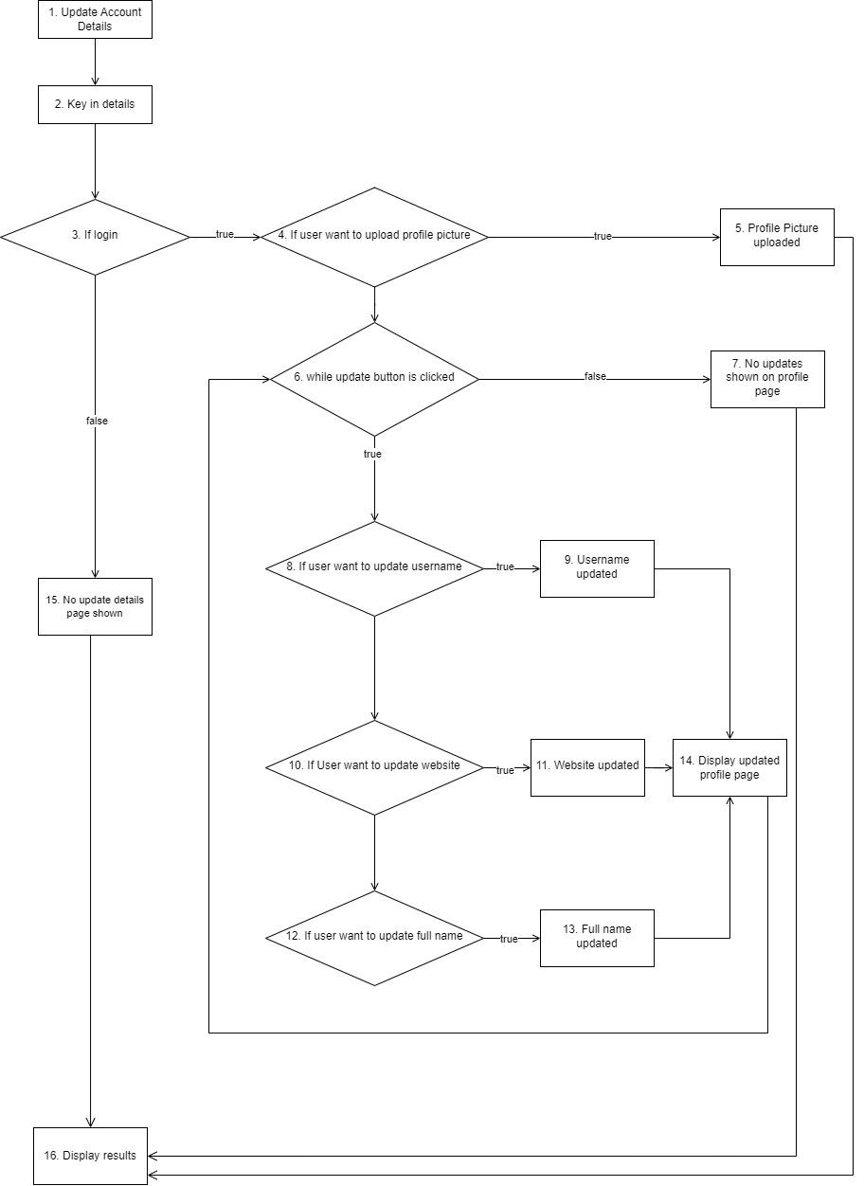

Cyclomatic complexity = 20-16+2=6 basic paths

| Basic Path | Test input | Expected Output | Actual Output | Passed |
| --- | --- | --- | --- | --- |
| 1, 2, 3, 4, 6, 7, 16 | Login = True;  Upload_profilepic = NULL;  Update_button = False; Update_username = NULL;  Update_Website = NULL;  Update_Fullname = NULL | No changes in profile page | No changes in profile page | Pass |
| 1, 2, 3, 15, 16 | Login = False;  Upload_profilepic = NULL;  Update_button = NULL; Update_username = NULL;  Update_Website = NULL;  Update_Fullname = NULL | Login page shown | Login page shown | Pass |
| 1, 2, 3, 4, 5, 16, 6, 7, 16 | Login = True;  Upload_profilepic = True;  Update_button = NULL; Update_username = NULL;  Update_Website = NULL;  Update_Fullname = NULL | Profile picture is uploaded | Profile picture is uploaded | Pass |
| 1, 2, 3, 4, 6, 8, 9, 14, 10, 12, 6, 7, 16 | Login = True;  Upload_profilepic = NULL;  Update_button = True; Update_username = True;  Update_Website = NULL;  Update_Fullname = NULL | Username updated in profile page | Username updated in profile page | Pass |
| 1, 2, 3, 4, 6, 8, 10, 11, 14, 12, 6, 7, 16 | Login = True;  Upload_profilepic = NULL;  Update_button = True; Update_username = NULL;  Update_Website = True;  Update_Fullname = NULL | Website updated in profile page | Website updated in profile page | Pass |
| 1, 2, 3, 4, 6, 8, 10, 12, 13, 14, 6, 7, 16 | Login = True;  Upload_profilepic = NULL;  Update_button = True; Update_username = NULL;  Update_Website = NULL;  Update_Fullname = True | Full name updated in profile page | Full name updated in profile page | Pass |

Upcoming notification

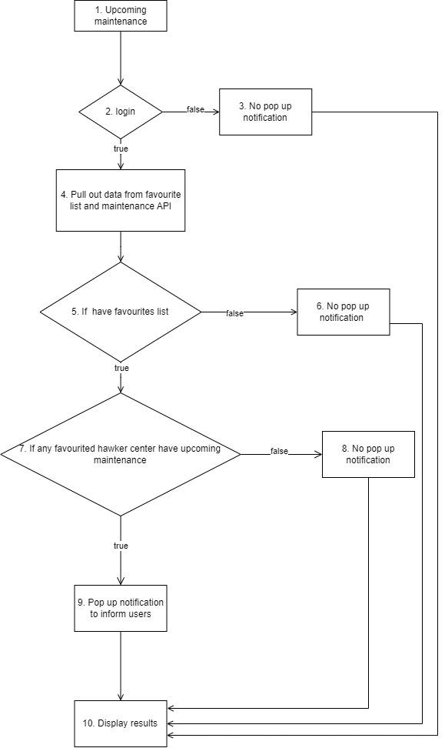

Cyclomatic complexity = 12 - 10 +2 = 4 basic paths

| Basic Path | Test input | Expected output | Actual output | Passed |
| --- | --- | --- | --- | --- |
| 1,2,4,5,7,9,10 | Login = True; Favlist_exist = True;  Fav_hawk_date = True | Pop up notification to inform users for upcoming maintenance | Pop up notification to inform users for upcoming maintenance | Pass |
| 1,2,3,10 | Login = False; Favlist_exist = NULL;  Fav_hawk_date = NULL | No pop up notification | No pop up notification | Pass |
| 1,2,4,5,6,10 | Login = True; Favlist_exist = False;  Fav_hawk_date = NULL | No pop up notification | No pop up notification | Pass |
| 1,2,4,5,7,8,10 | Login = True; Favlist_exist = True;  Fav_hawk_date = False | No pop up notification | No pop up notification | Pass |